COMP2322 COMPUTER NETWORKING

Project

Multi-threaded program

Name: Chong Zhi Yi
Student ID: 23078028d

Summary of design and implementation
This server program implements a multi-threaded HTTP web server in Python. It is designed to handle multiple client requests concurrently and serve static files from a specified directory (httpdoc). Below is an overview of its design and implementation:

Design Overview
Socket-Based Communication:
- The server uses the socket module to create a TCP socket that listens on 127.0.0.1 (localhost) at port 8080.
- It accepts incoming client connections and processes HTTP requests.
Multi-Threading:
- Each client connection is handled in a separate thread using the threading module.
- The main thread accepts connections and spawns a new thread for each client, assigning the request handling to the “handle_client” function.
HTTP Protocol Support:
- The server supports basic HTTP methods: GET, which retrieves the content of a file; HEAD, which retrieves only the headers of a file.
- It handles HTTP headers like If-Modified-Since and Connection.
Static File Serving:
- Files are served from the httpdoc directory.
- The server determines the file type based on the file extension (e.g., .html, .txt, .png).
- It checks file existence, permissions, and type before serving.
Error Handling:
- The server generates appropriate HTTP responses for various scenarios:
- 200 OK: File successfully retrieved.
- 304 Not Modified: File has not been modified since the date in the If-Modified-Since header.
- 400 Bad Request: Invalid or unsupported HTTP request.
- 403 Forbidden: File exists but is not readable.
- 404 Not Found: File does not exist.
- 415 Unsupported Media Type: File type is unsupported.

Implementation Details
Core Functions:
- get_file_type(filename):
- Determines the MIME type of file based on its extension.
- generate_http_response(status_code, headers, body=''):
- Constructs an HTTP response with the given status code, headers, and body.
- handle_if_modified_since(headers, filepath):
- Checks if the file has been modified since the date in the If-Modified-Since header and returns a 304 Not Modified response if applicable.
- handle_request(request):
- Parses the HTTP request, validates it, and generates an appropriate response based on the request type and file status.
- handle_client(client_connection):
- Processes a single client connection by receiving the request, calling “handle_request”, and sending the response.
Multi-Threading:
  - The main thread listens to incoming connections and spawns a new thread for each client.
File Handling:
  - Files are accessed using os.path functions to check existence, permissions, and type.
  - The server reads file content and metadata (e.g., last modified date) to generate responses.
Socket Management:
  - The server socket is configured with SO_REUSEADDR to allow quick restarts.
  - Each client connection is closed after the response is sent.

Demonstration of executing the program
Step 1: Run the Server.py program
- Type “python Server.py” in terminal
- Expected output: Listening on port 8080
Step 2: Run the Client.py program
- Type “python Client.py” in a separate terminal
- Excepted output: Server response:

Screen capturing results of functions
- send_http_request('GET', '/helloworld.html', 'keep-alive') 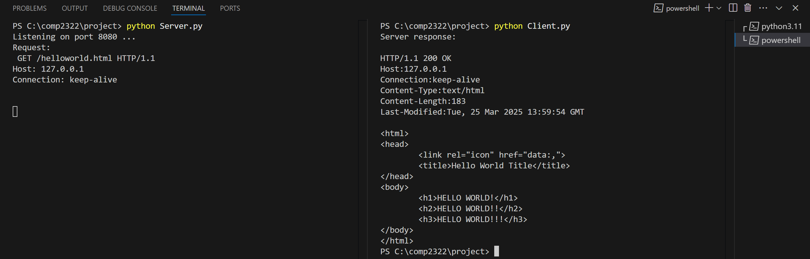

- send_http_request('HEAD', '/helloworld.html', 'close') 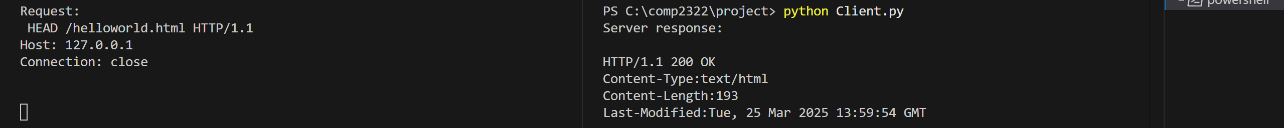

- send_http_request('POST', '/helloworld.html', 'close') 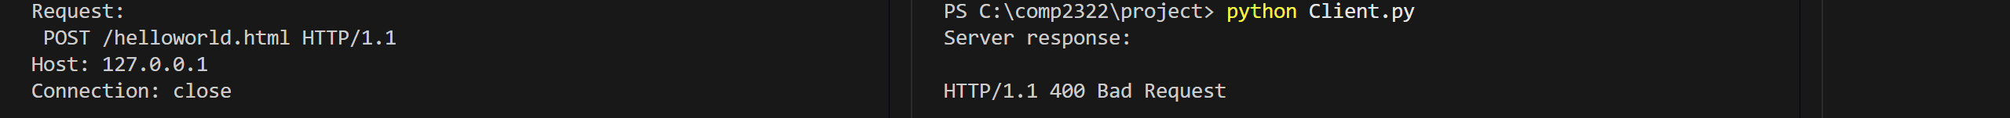

- send_http_request('GET', '/nonexistentfile.html', 'close') 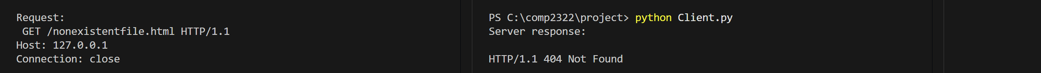

- send_http_request('GET', '/index.html', 'close') 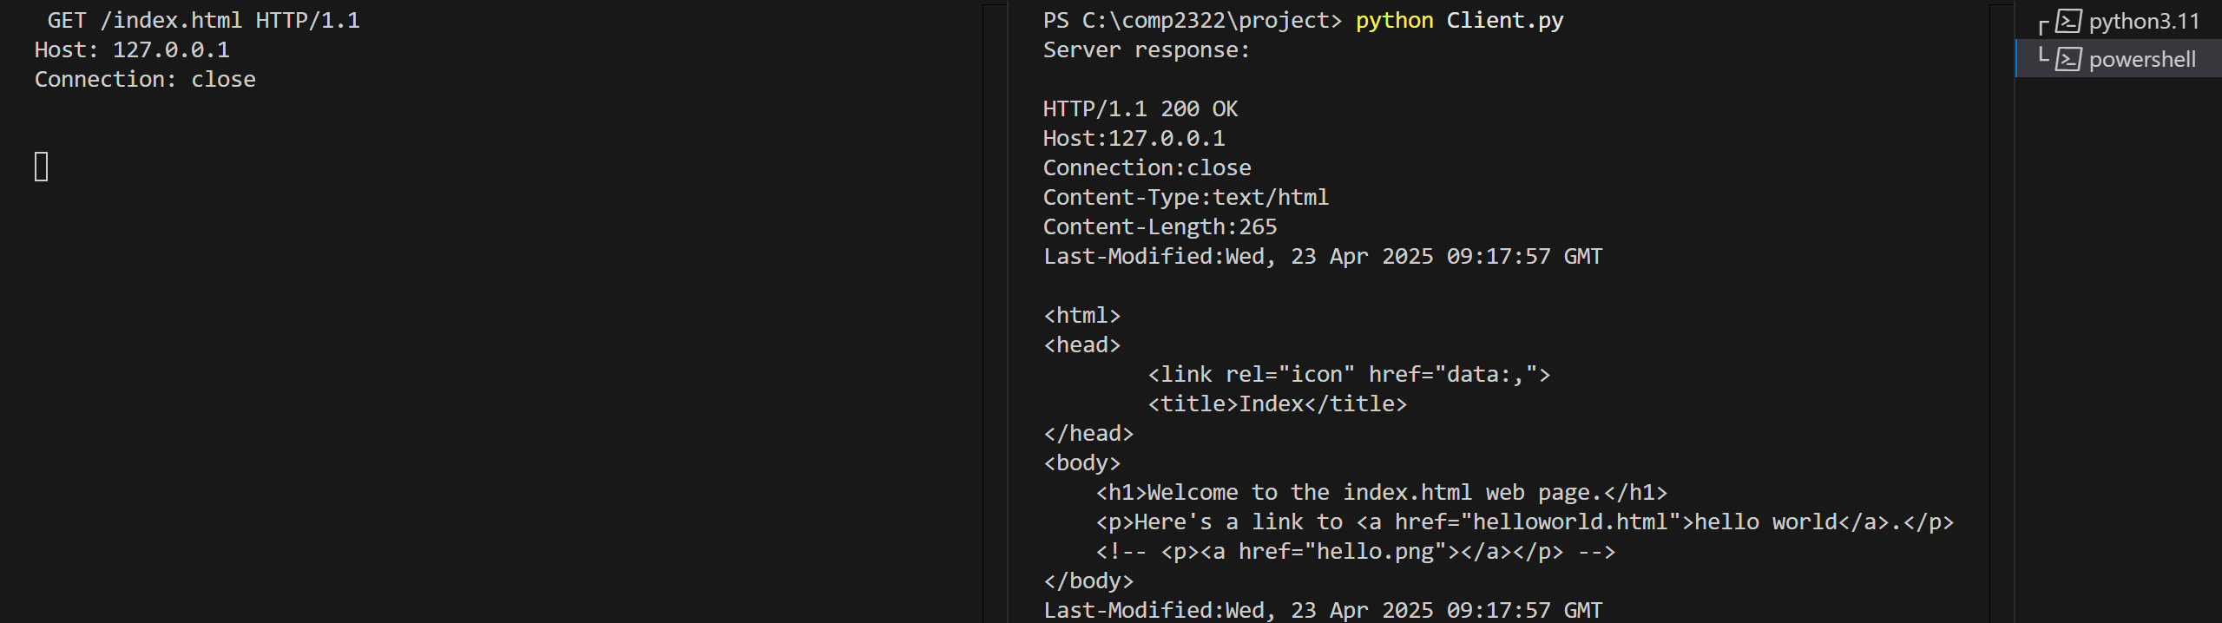

- send_http_request('GET', '/helloworld.pdf', 'close') 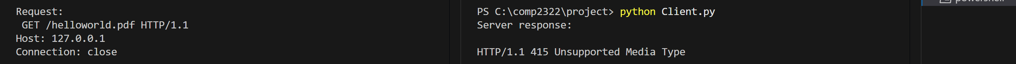

- send_http_request('GET', '/forbidden.html', 'close') 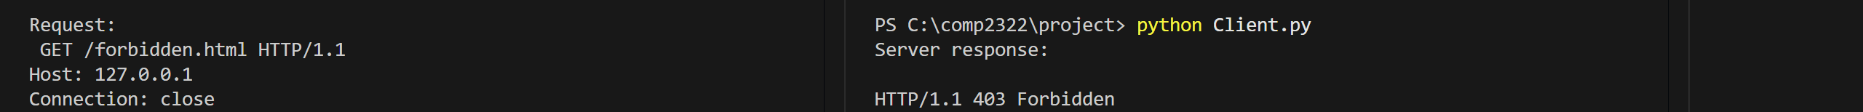

Log file
